1. Open Visual Studio 2022
2. Select “Create a new project”

1. Create a ASP.NET Core Empty project

1. Type a solution name and a file name.

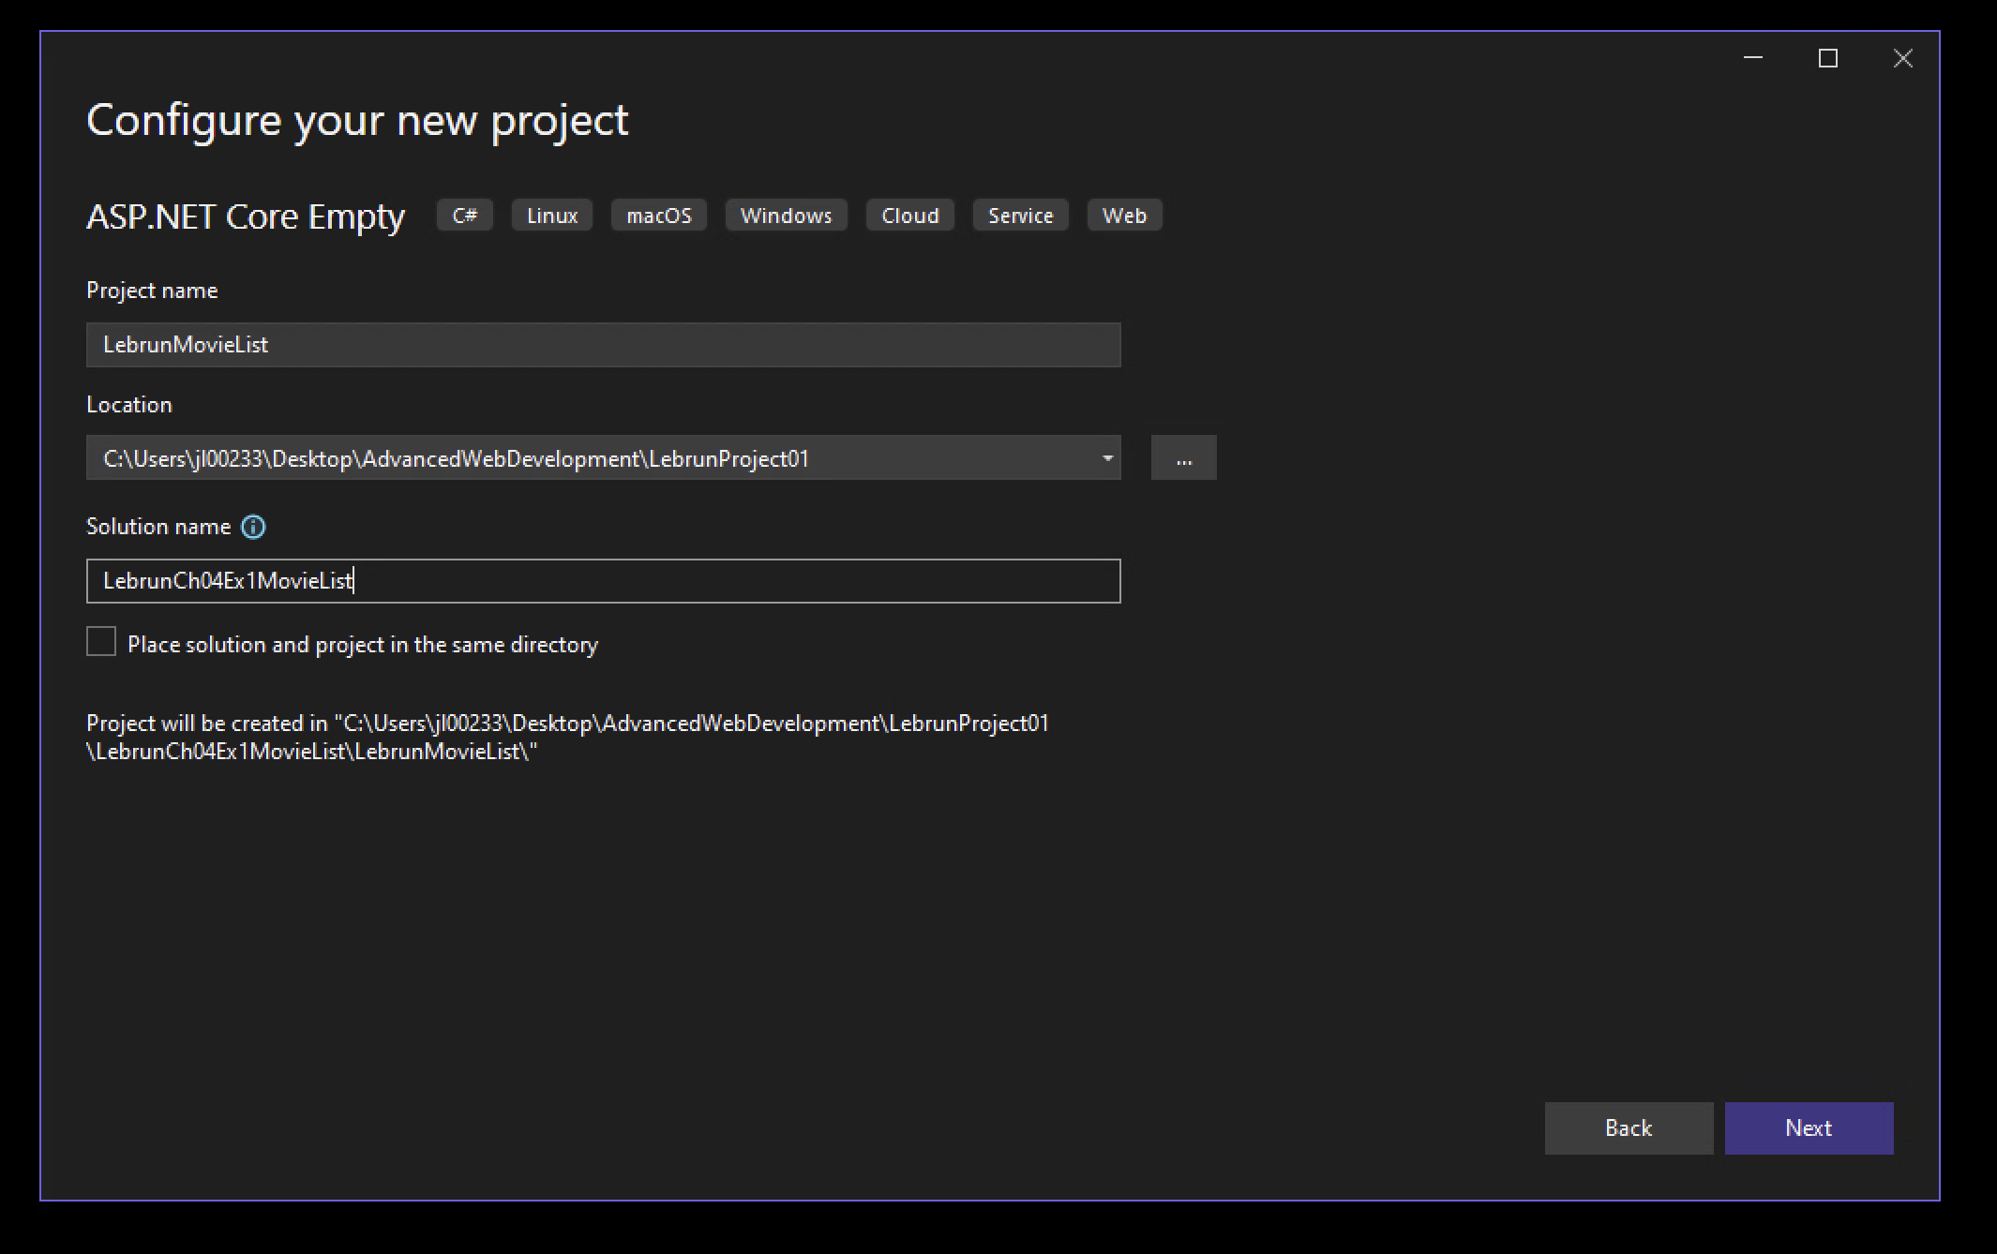

1. Create a location for the project. Ex:LebrunCh04Ex1MovieList/ex_starts

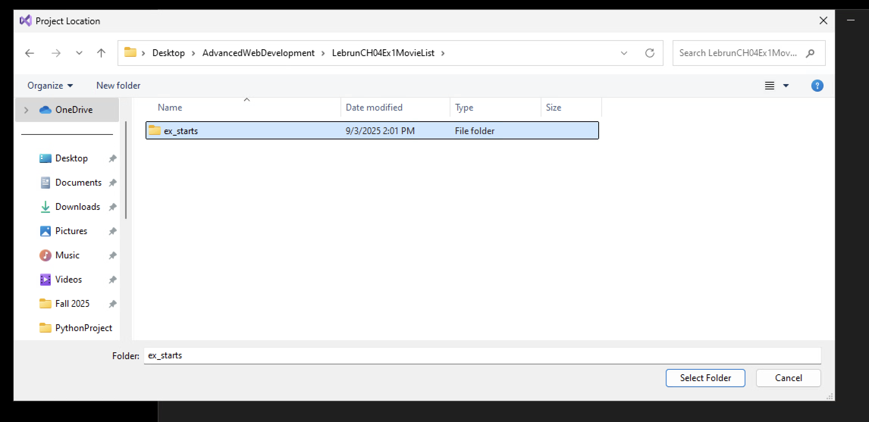

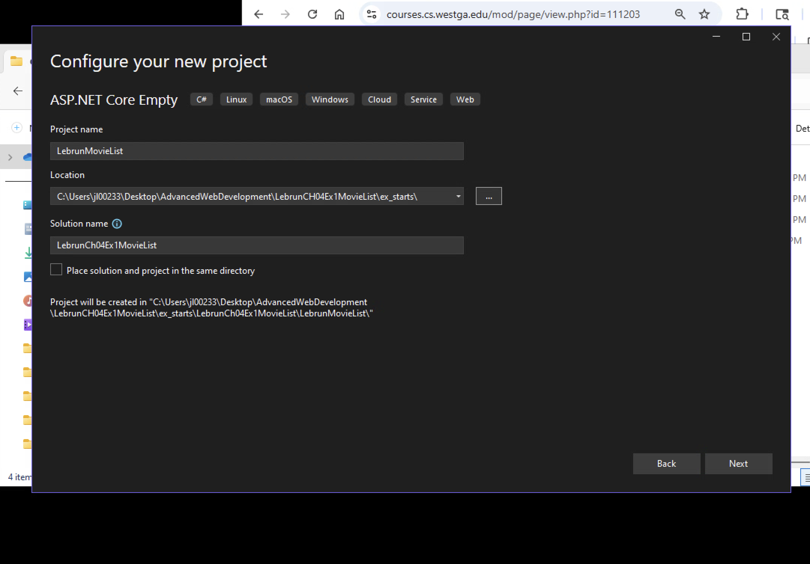

6.Select configuration based on the set-up show below. Then select create.

7. Create the following folders in the solution project: Controllers, Models, Views. Within the Views folder, create the following subfolders: Home and Shared